CPSC 3720 Assignment #2 - Fall 2025: Sample Project 1
Team Members:
- Jiwon Jeon: Data Analysis & Visualization
- Chloe Lee: Data Processing & Computation
- Vergil Phan: Report Design & Documentation
Repository:
GitHub – AESO Renewable Forecast Analysis (August 2025)
📈 AESO Renewable Forecast Analysis — August 2025
- Overview
This project analyzes renewable energy forecast accuracy for Alberta (AESO) during August 2025, focusing on the relationship between solar and wind forecast performance and overall grid stability.
Data Sources:
- Solar_Data_2025_Aug.csv, Wind_Data_2025_Aug.csv — Forecast & Actual Data
- CSD Generation (Hourly) - 2025-08.csv — Total System Supply
Objectives:
- Evaluate forecast accuracy of solar and wind energy
- Assess total system supply variability (24-hour rolling standard deviation)
- Explore correlation between renewable forecast error and system volatility
- Key Results
Metric Solar Wind
Mean Absolute Percentage Error (MAPE) 17.5% 11.2%
Mean Absolute Error (MAE) 42.8 _{MW} 31.6 _{MW}
Forecast Coverage (within range) 78.0% 86.0%
- Wind forecasts were more stable and consistent than solar forecasts.
- Solar accuracy dropped notably during sunrise (7–9 AM) and sunset (6–9 PM).
- Most actual outputs (70–85%) fell within the predicted forecast range.

- Visual Findings
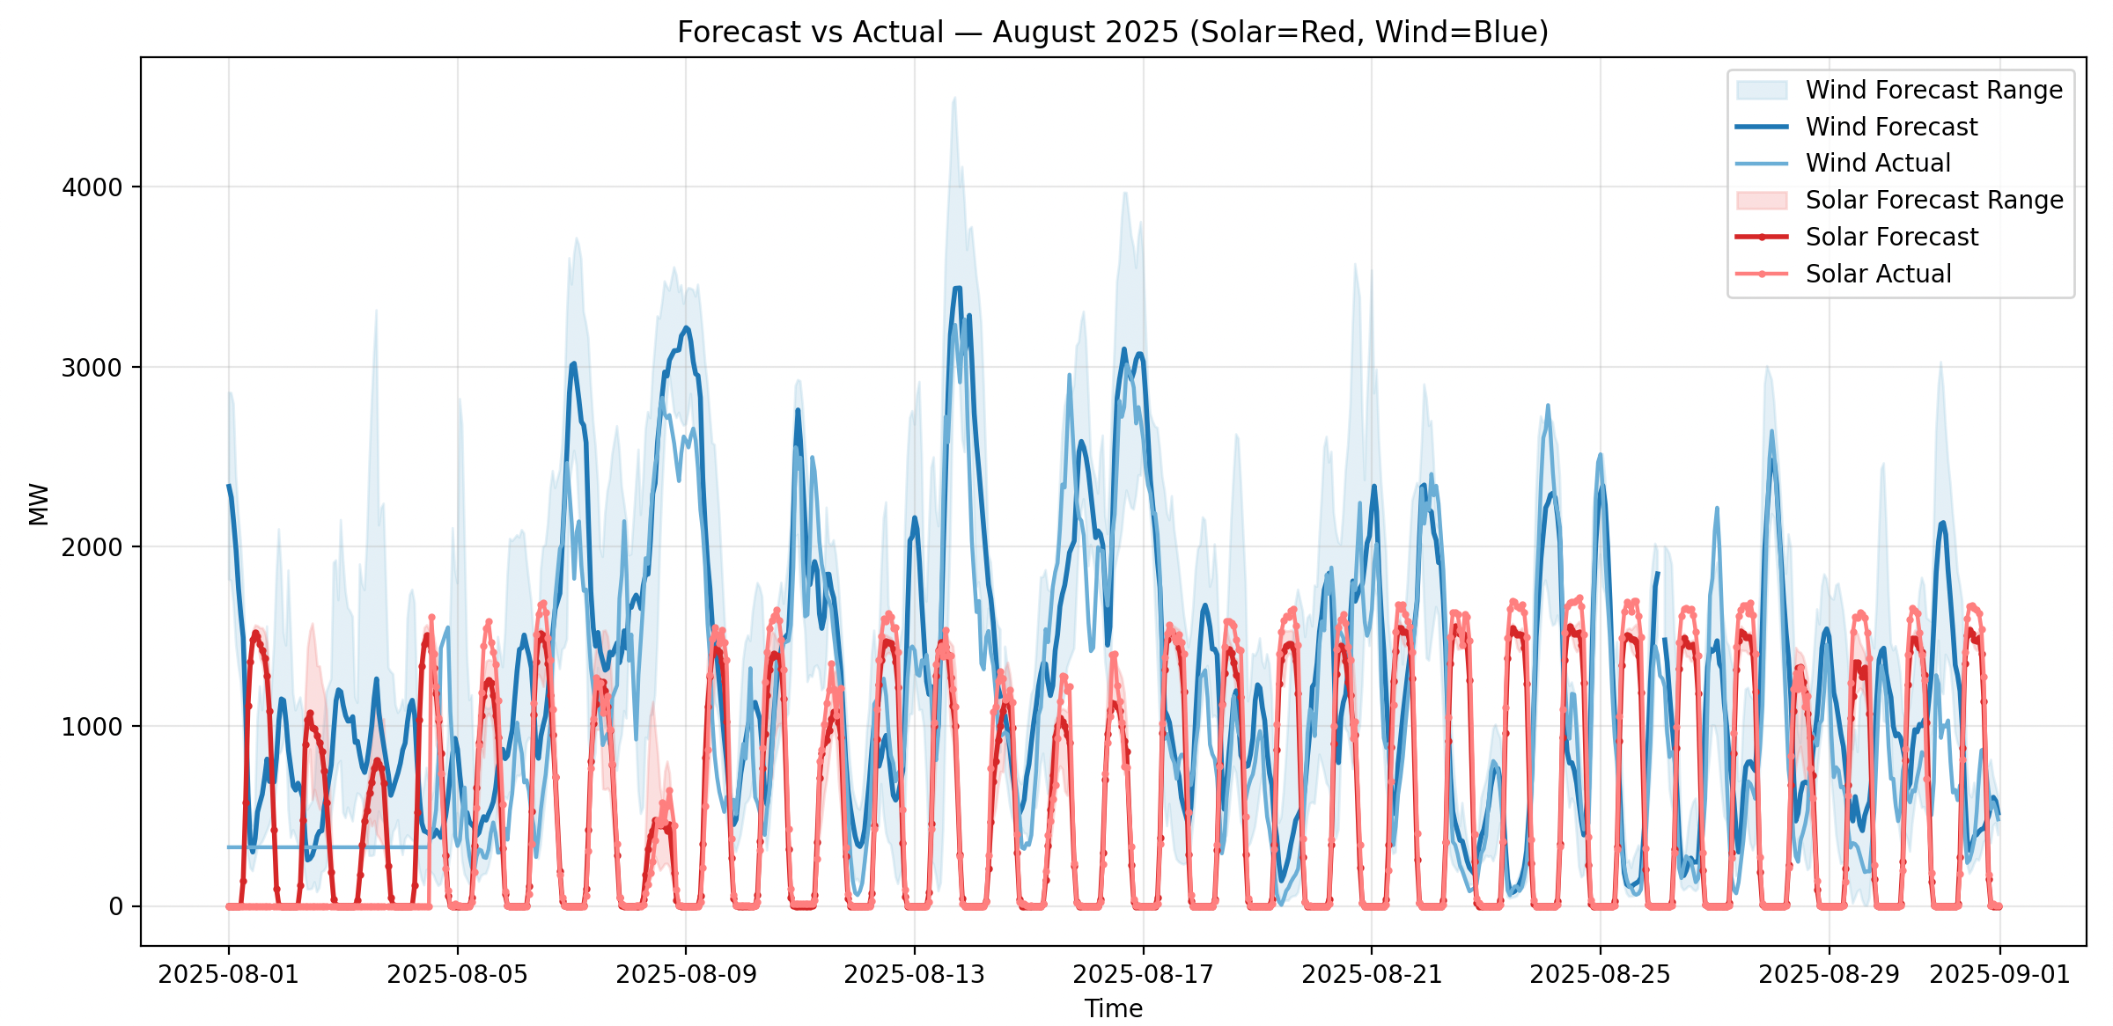
Figure 1.Solar and Wind Forecast vs Actual (2025-08)
- Red = Solar, Blue = Wind
- Wind forecasts align closely with actual outputs.
- Solar shows visible deviations during transitional light periods.
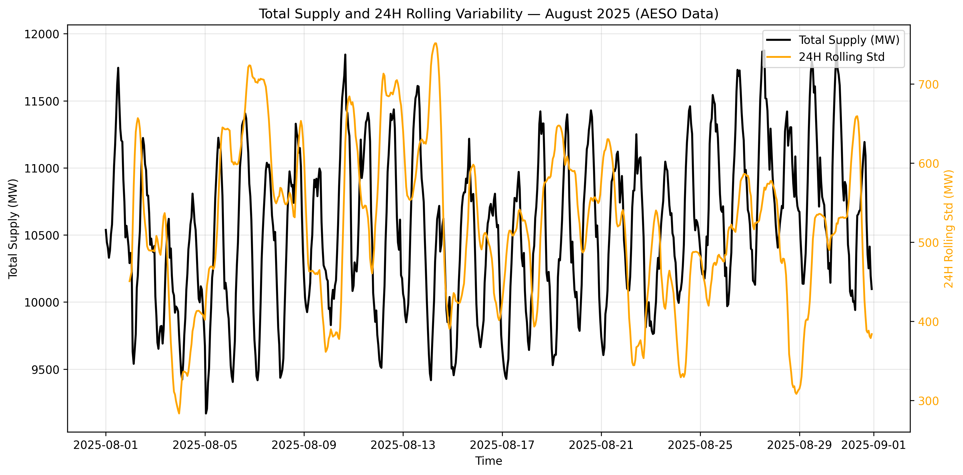
Figure 2. Total Supply & 24-Hour Rolling Variability
- Orange line = Volatility (Rolling Std)
- Peaks in volatility correspond with increased forecast error.
- Stable supply days (< 10% MAPE) show reduced variability.
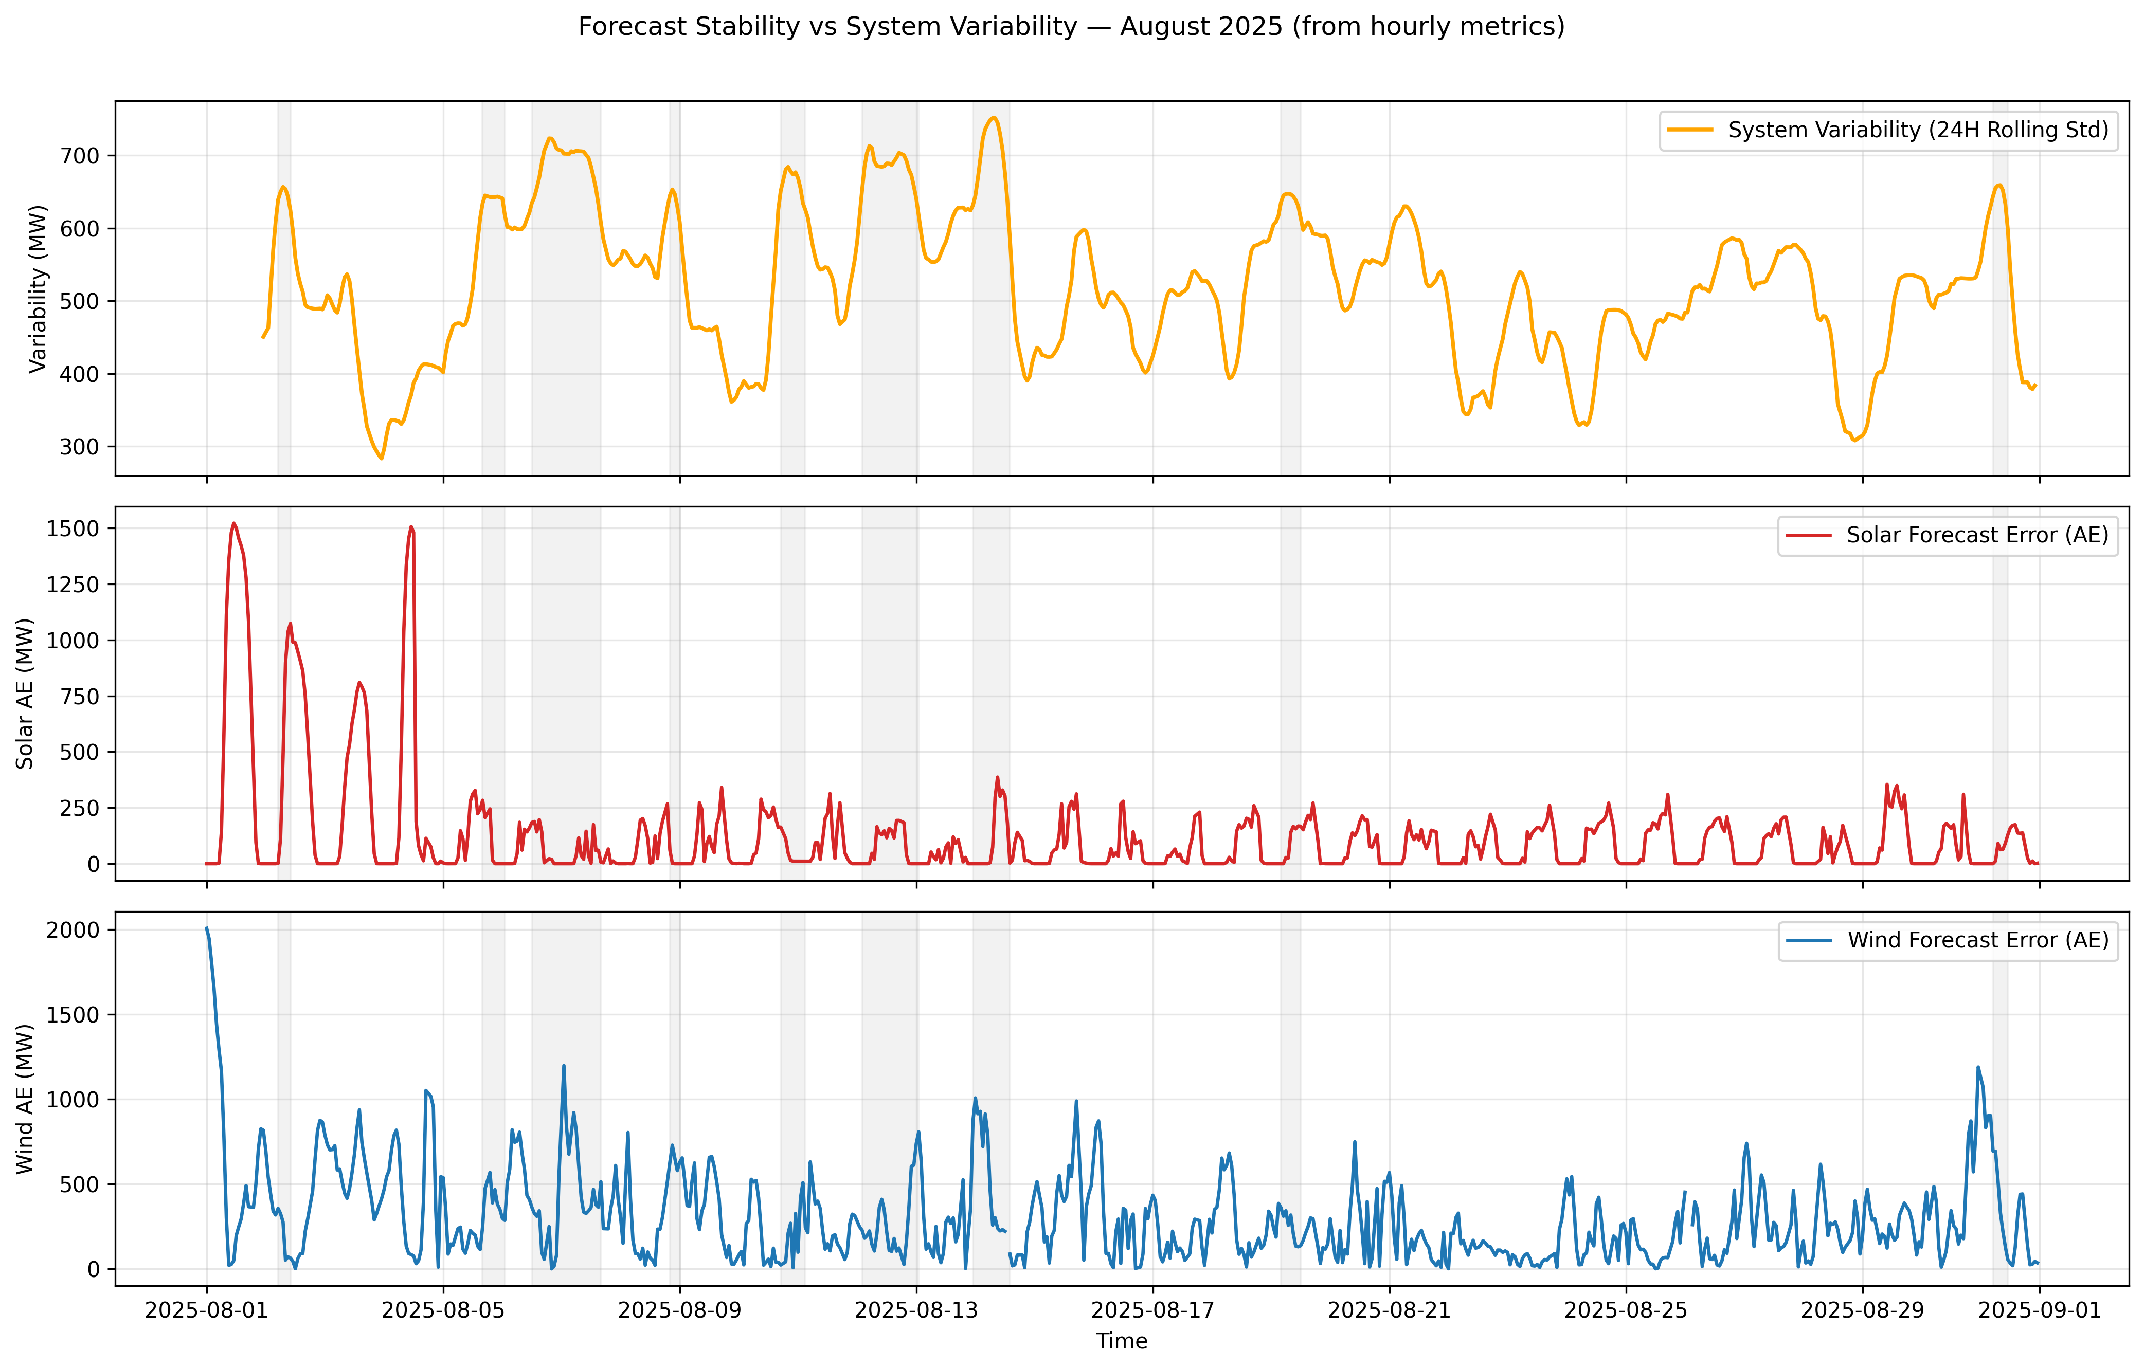
Figure 3.Stability Comparison hourly
- Top – Yellow: Total Supply 24H Rolling Std
- Middle – Red : Solar Absolute Error (AE)
- Bottom – Blue: Wind Absolute Error (AE)
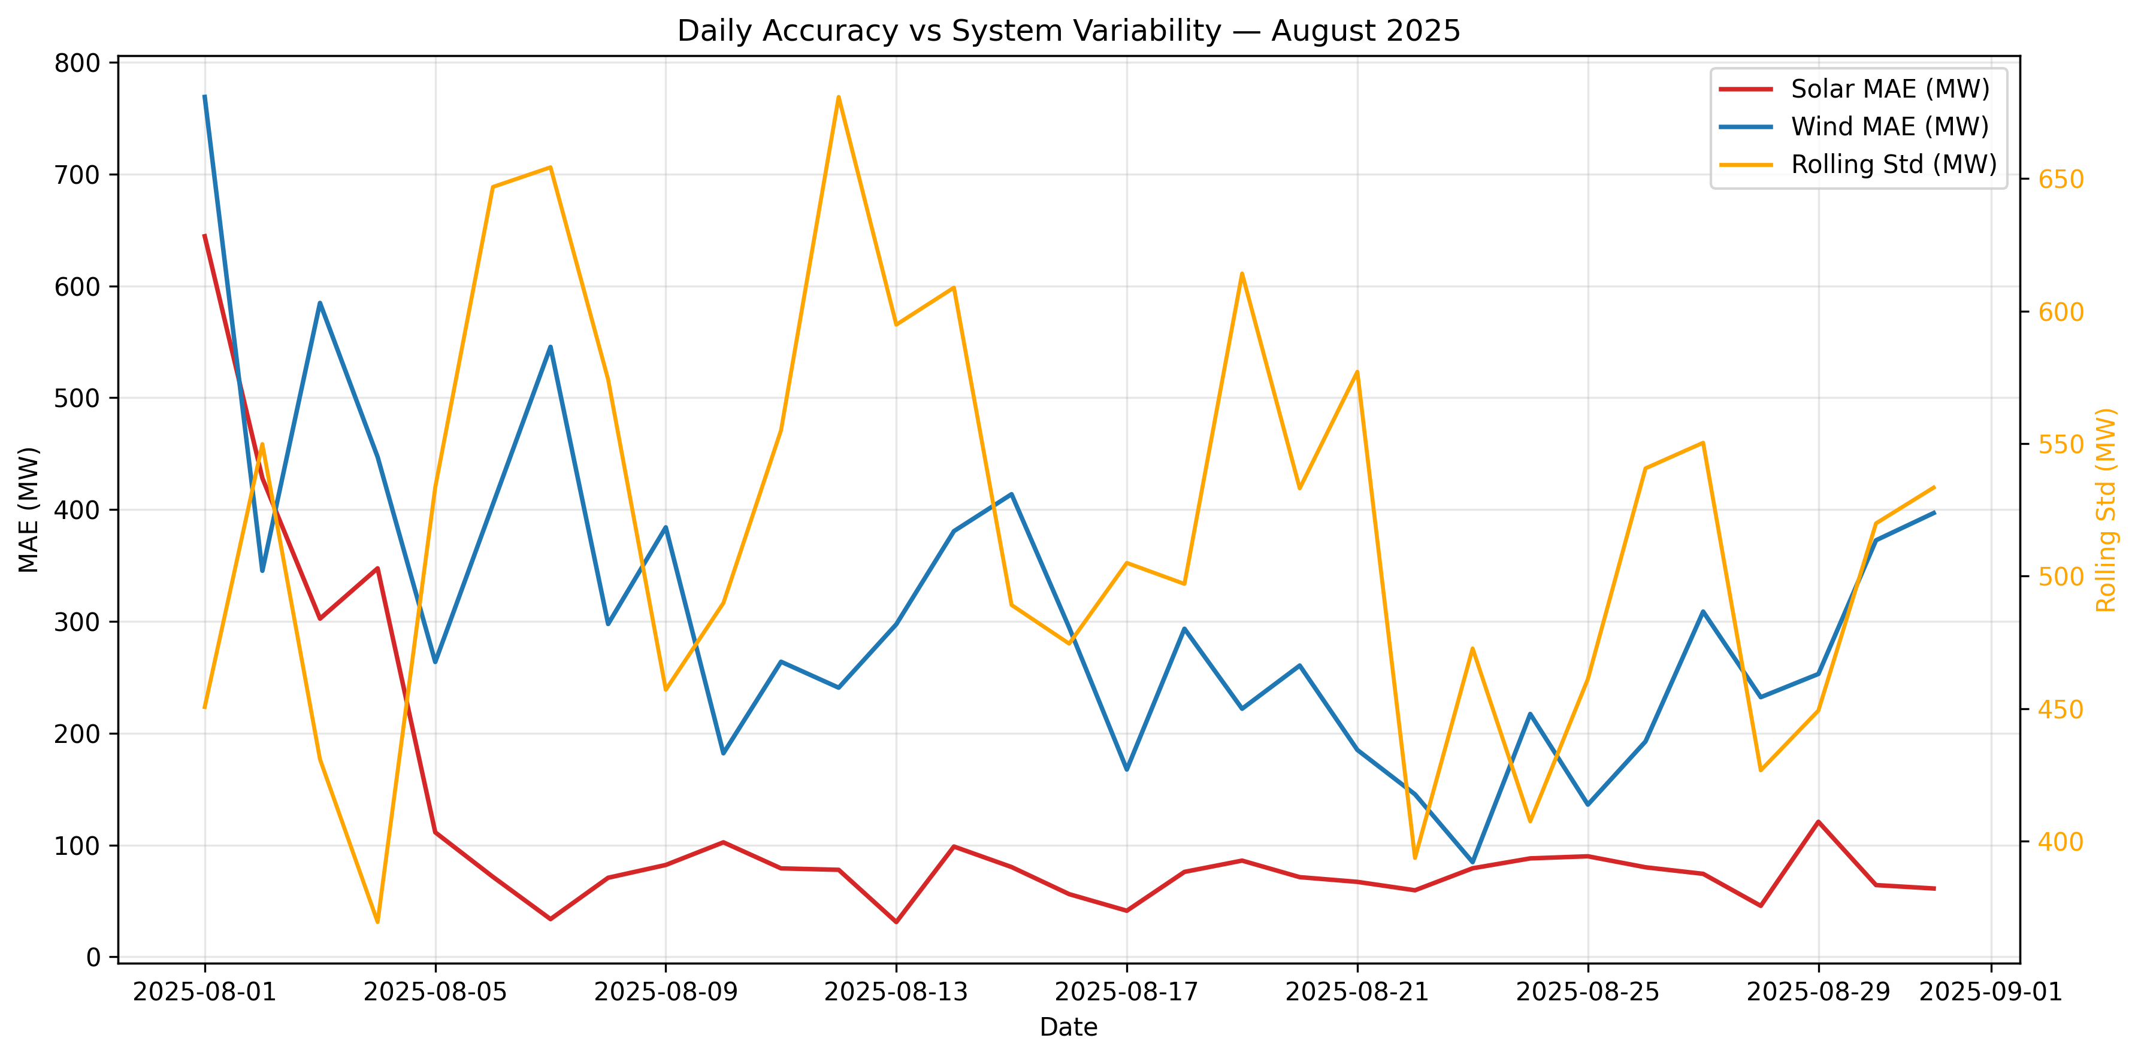
Figure 4.Stability Comparison Daily
This comparison reveals a negative correlation between supply stability and forecast error—periods with high variability tend to coincide with larger solar deviations, while wind remains more stable.

- Insights
- Wind energy shows higher predictability and resilience to supply fluctuations.
- Solar generation is more sensitive to transient weather and irradiance variability.
- Volatility-aware forecasting could reduce solar prediction errors.
- Monitoring supply variability enhances grid stability and forecasting reliability.

- Recommendations
- Integrate localized weather & irradiance data into solar forecasting models.
- Employ ensemble hybrid models (statistical + ML) for adaptive prediction.
- Implement rolling-window volatility dashboards for real-time operational alerting.
- Use automated pipelines for continuous data ingestion and monthly retraining.

- Deliverables Summary
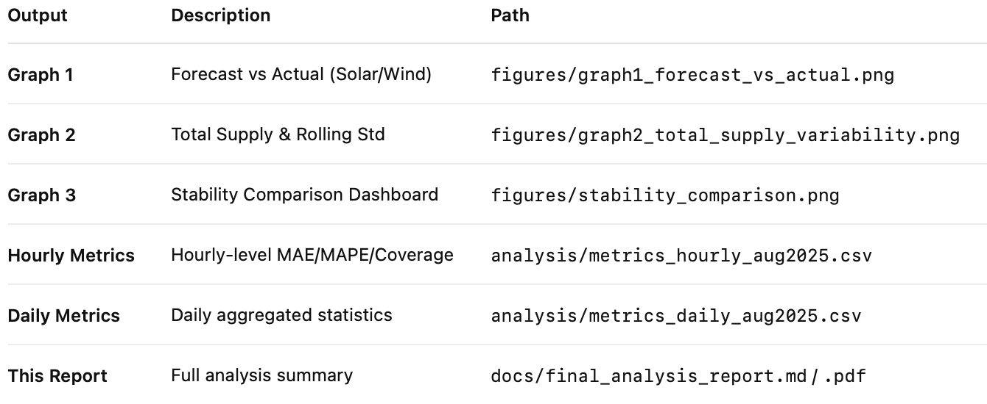

- Conclusion
Wind forecasting achieved higher accuracy and greater stability than solar in August 2025. System volatility strongly influenced solar forecast errors, emphasizing the need for volatility-aware modeling. Wind energy contributed more consistently to grid stability, while solar performance can be improved through better irradiance modeling and predictive adaptability.
- Folder ready for submission:
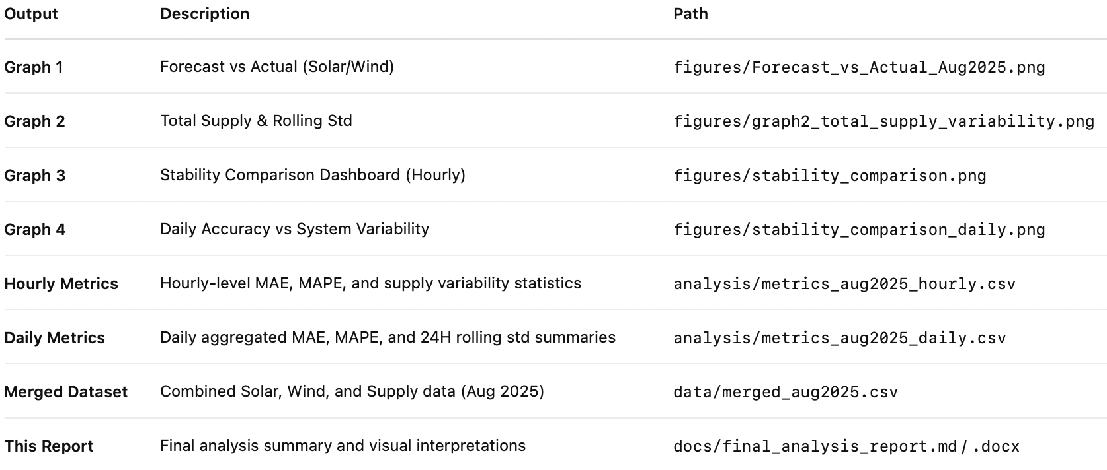

- References / Data Source
Alberta Electric System Operator (AESO). Market and Operations Data. Retrieved Oct 2025 from https://www.aeso.ca/market/operations/
Python Libraries: pandas v2.2, matplotlib v3.8, numpy v1.26.

